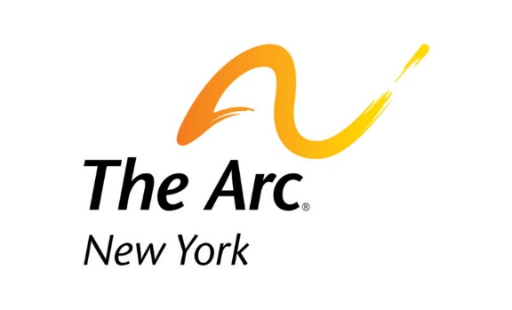
Advocacy Toolkit

Support the Better Care Better Jobs Act and I/DD Direct Care Workforce
Template Letter
My name is [advocate] and I am a constituent and supporter of New Yorkers with intellectual and developmental disabilities (I/DD). They are our family, friends, loved ones, and members of our community. Right now we need your help to support them with dedicated and sustainable workforce funding.
The repercussions from the COVID-19 pandemic are still being felt as providers of home and community based services (HCBS) face a severe shortage of Direct Support Professionals (DSP) and few additional resources by which to recruit and retain staff. A recent survey conducted by New York Disability Advocates (NYDA) found that 25% of DSP positions are currently vacant statewide – a 75% increase in vacancy rates since pre-pandemic levels. Ninety-three percent of providers saw a decrease in job applicants this year, and 48% of providers were forced to close or reduce programs due to lack of staff. This is not just a looming crisis; it is an emergency.

DSPs are essential workers who provide daily care, services and supports to people with intellectual and developmentally disabilities 24 hours a day, 7 days a week. These workers – the majority of whom are women – have been underpaid and undervalued for too long. Caring for people with complex needs is a rewarding yet challenging job, which requires ongoing training, high-level of responsibility, and skill.
For these reasons we are asking you to sponsor the Better Care Better Jobs Act (BCBJA), sponsored by Senators Bob Casey and Ron Wyden and Representative Debbie Dingell. This is a once in a generation chance to create the care economy infrastructure that New Yorkers need, while providing increased wages, career ladders, and opportunities for DSPs, who are the backbone of the system of supports and services that people with I/DD and their families depend on. Having a permanent 10 percentage point increase in the federal Medicaid match for delivering HCBS in addition to funding for improvements and innovation would be life changing.
Expanding HCBS would help eliminate waiting lists, and pave the way for much deserved DSP compensation, recognition, and career paths. Additional pieces of legislation to sponsor are S.1437 - Recognizing the Role of Direct Support Professionals Act, which would establish a Standard Occupational Classification (SOC) for DSPs, a big stepping stone towards acknowledging their true scope of work, and H.R.2999 - Direct Creation, Advancement, and Retention of Employment (CARE) Opportunity Act, which provides resources to support and grow our workforce
I cannot stress enough the importance of investing in our care infrastructure and your support of the Better Care Better Jobs Act. Not only will these funds go directly into our local economy, but it will vastly improve the quality of life for DSPs and the individuals they support.
Thank you for your time and I look forward to your response.
Sincerely,
[Advocate Name]

